|  |
| --- |
| BENZIR STUDIOS |
| Assignment 3- 3D Game |
| **Simple 3D Game** |
| Version #01  All work Copyright © 2015 by Benzir Games.  All rights reserved. |
| **Benzir Ahmed** |
|  |

|  |
| --- |
| May 16th 2012 |

**Table of Contents**

# Version History

## November 16

* Asset Collection
* Terrain/ Platform made

## November 17

* Asset Collection( coin, mine, health)
* Imported assets into the game
* Game controller script
* Player collider script

## November 19

* Score system- added points, live counter, health
* Added wind, trees

## November 20

* Finial edits

## Github

<https://github.com/ahmedb7/Assignment3_3D-Game>

[This is the body of your video game design document. You should add and delete sections as they pertain to your game’s design.]

1. **Game Overview** 
   1. **Collection of Coins**
   2. **Avoid mines**
   3. **Collect health packs if injured**
2. **Game Play Mechanics**

*Standard WASD for player movement, shift to run, space to jump*

1. **Camera**

*Single perspective*

1. **Controls**

*WASD to move, shift to run, space to jump*

1. **Interface Sketch**

*(What does the game interface look like? Provide a screen shot or sketch)*

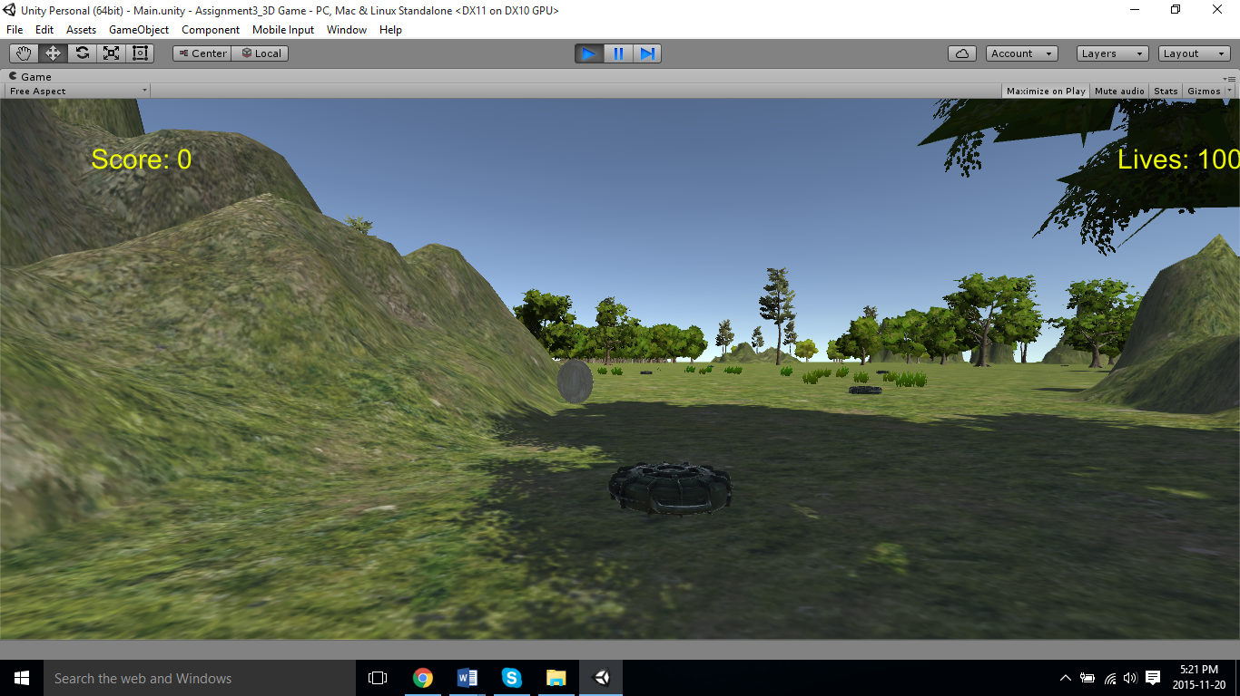

1. **Game World**

*You are in a mountainous region, full of land mines, avoid the mines collect the gold coins.*

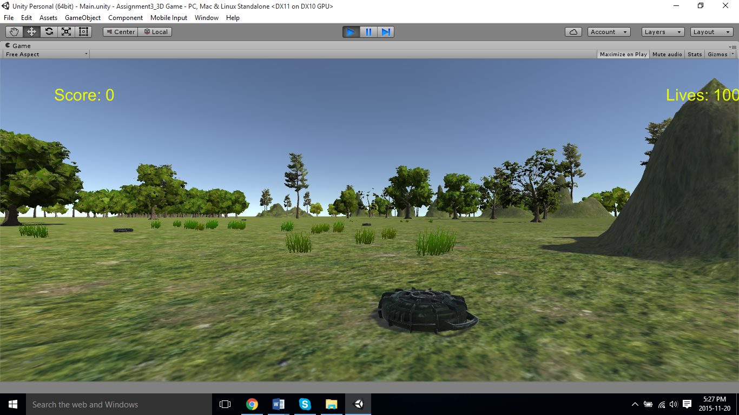

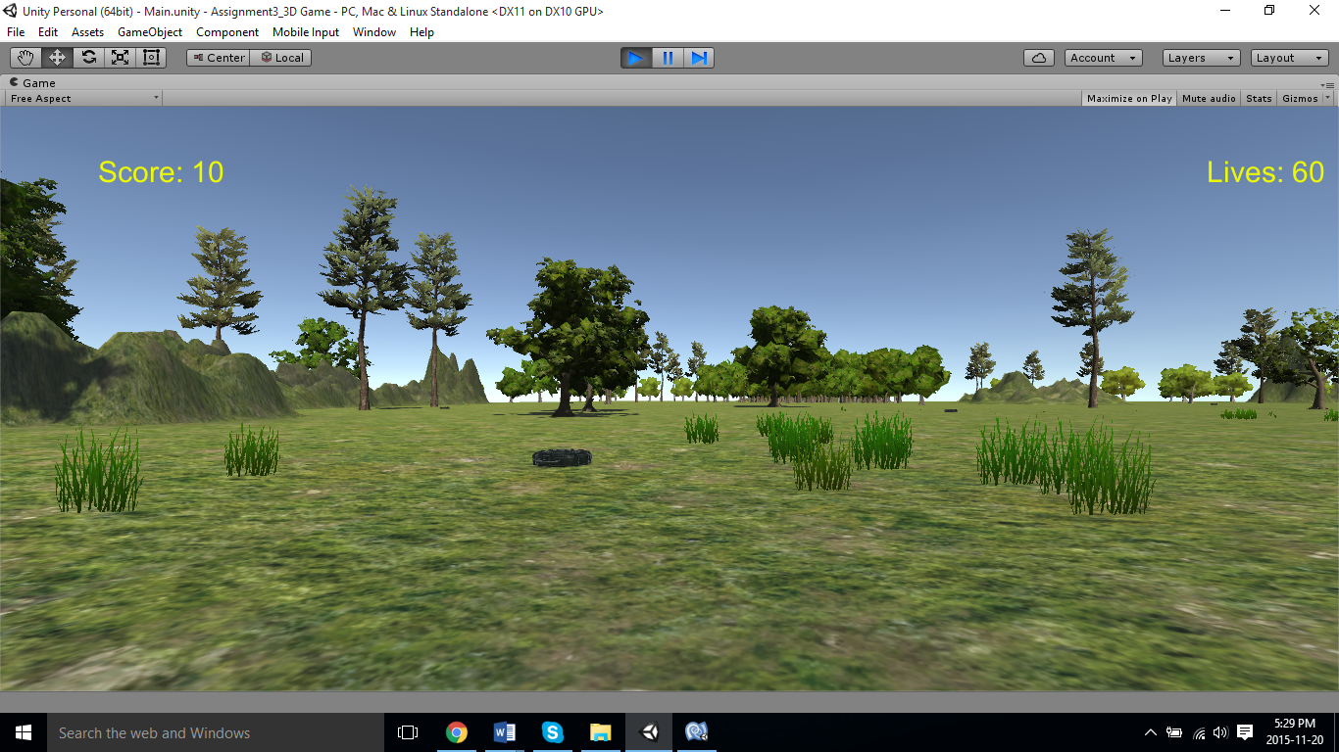

1. **Levels**

*Single Level*

1. **Game Progression**

Game ends after player collects all coins

1. **Characters**

*Capsule, does not have a body, but moves in a first person fashion*

1. **Non-player Characters**

Coins – Gives out 10 points

Mines – damages player by 20 hit points

Health pack – restores 20 HP

1. **Enemies**

Mines – damages player by 20 hit points

1. **Weapons**

*None*

1. **Items**

Coins – Gives out 10 points

Mines – damages player by 20 hit points

Health pack – restores 20 HP

1. **Script**

GameController.cs – Game score and life controller

PlayerCollider.cs – player collisions

1. **Sound Index**

*(Include an index of all your sound clips)*

1. **Story Index**

*(Outline your game story here)*

1. **Art / Multimedia Index**

* Small Survival Pack(Health pack): <https://www.assetstore.unity3d.com/en/?gclid=Cj0KEQiApruyBRCFqoDu1pbk9rkBEiQAF8EFdU-XJl4Xzb1vheUAOCo1FVbkTJO4hvoq0iIdDaRrCoQaAprc8P8HAQ#!/content/20565>
* AT- Mines: <https://www.assetstore.unity3d.com/en/?gclid=Cj0KEQiApruyBRCFqoDu1pbk9rkBEiQAF8EFdU-XJl4Xzb1vheUAOCo1FVbkTJO4hvoq0iIdDaRrCoQaAprc8P8HAQ#!/content/37653>
* Maze Generator ( coins): <https://www.assetstore.unity3d.com/en/?gclid=Cj0KEQiApruyBRCFqoDu1pbk9rkBEiQAF8EFdU-XJl4Xzb1vheUAOCo1FVbkTJO4hvoq0iIdDaRrCoQaAprc8P8HAQ#!/content/38689>

1. **Future Features**

*Adding more levels*